20CSE1030 Zubin Shah Section B

1. Write a program with function to add given 2 integer numbers
2. Where the function return type is void and no parameters are passed to function

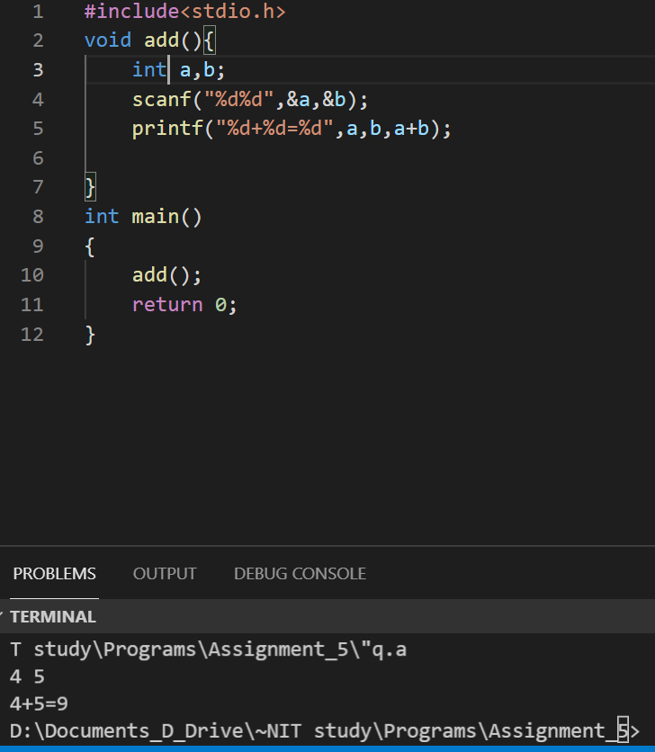

1. When parameters are passed to function and function return type is void

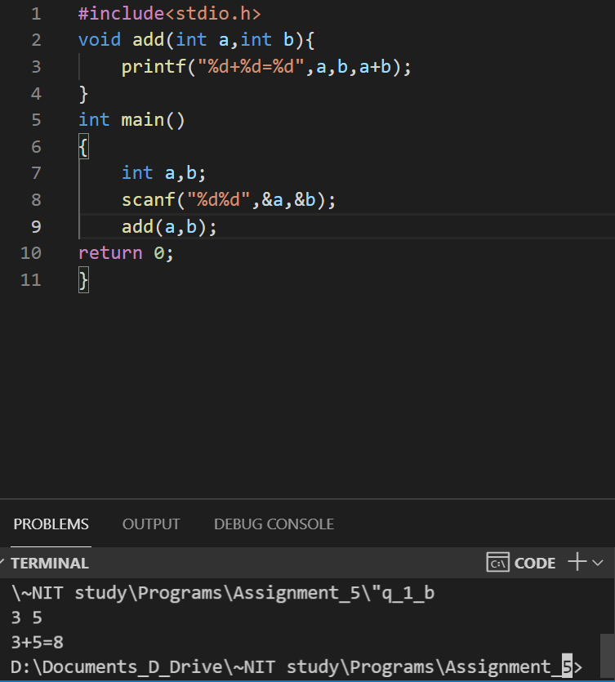

1. When parameters are passed and function returns a result

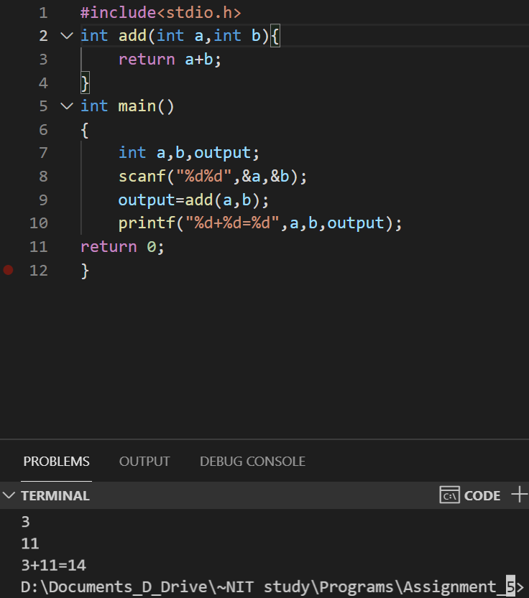

1. Write a program with a function to swap 2 numbers.

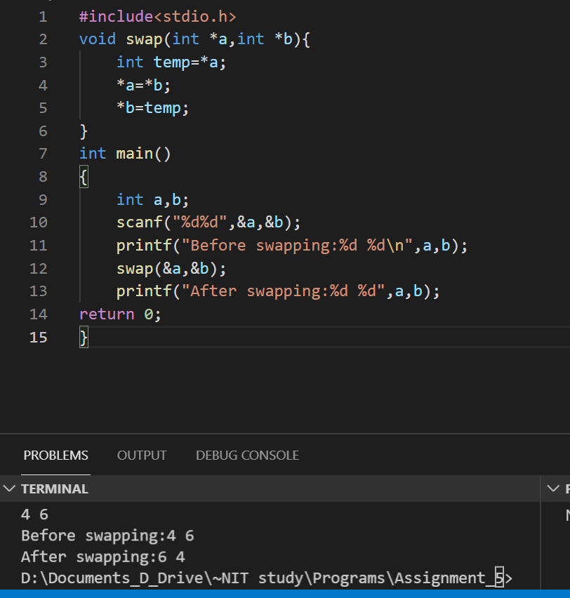

1. Write a program with a function to find the power of numbers.

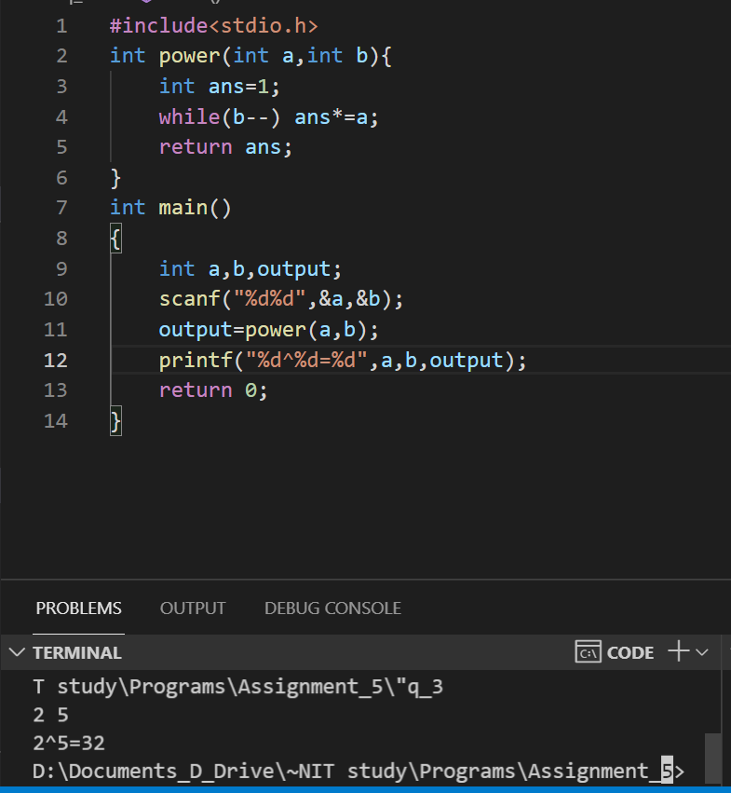

  4. Write a program  with a function to find the sum of the first 50 natural numbers. The return   type must be void and the result is expected to be printed in the main function.

